Applicants guide to enquire portal.

Creating a new account

Navigate to the Scholarship application Portal Register page and enter your details to be used as contact information for your scholarship application. Create a password and confirm your password. If you are a returning applicant, you can use the log in section and provide your current details, if required there is a forgot your password facility.

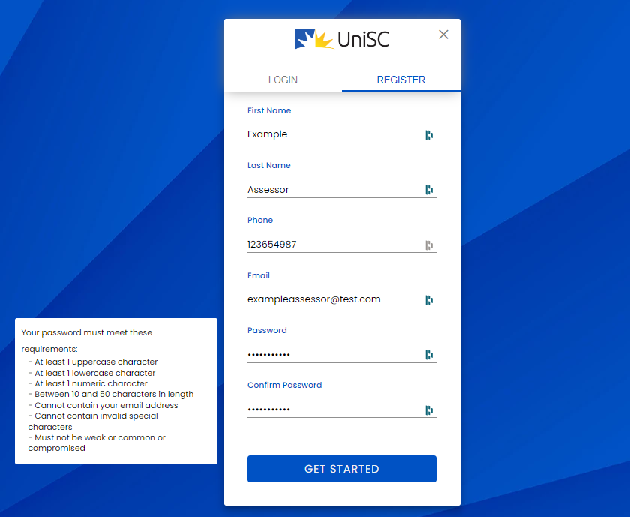

Once you set your password, you will be prompted to complete your user profile and complete the terms and conditions declaration.

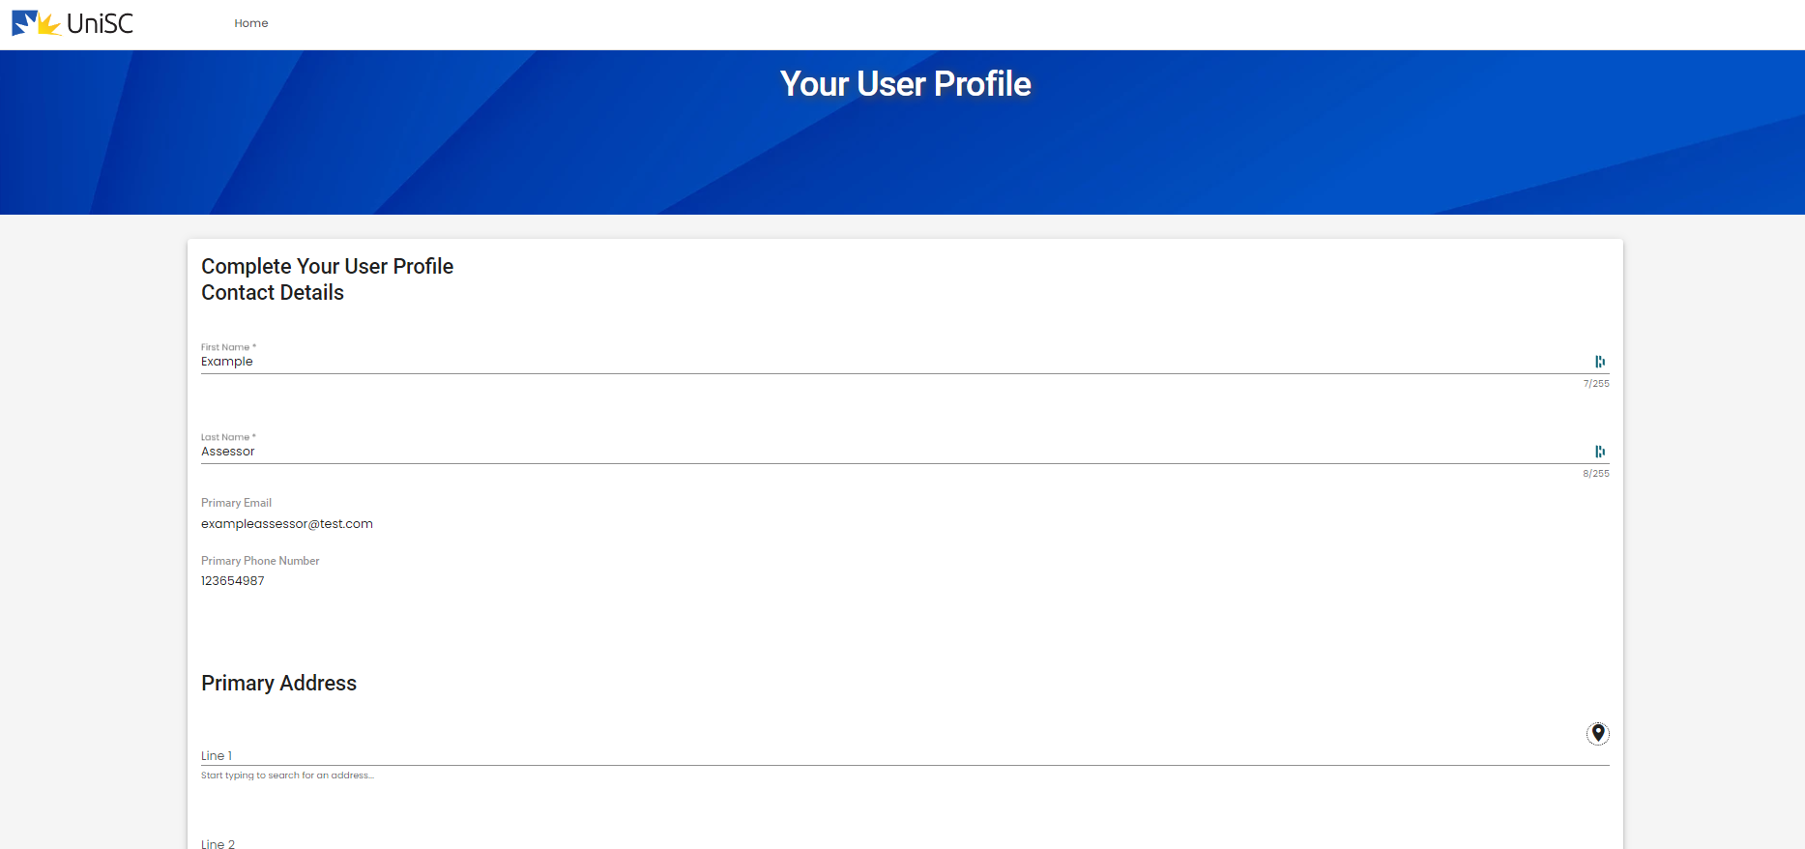

Once your complete your profile, the final step is to hit Register.

Inside the scholarship portal

1) Once logged in you will now be navigated to the Scholarship Portal Home Page which is where you will always land after logging in.

- Highlighted in red (central right) are the quick apply buttons for scholarships which are currently open for application.
- Highlighted in yellow (top left) is the link to additional information about scholarship opportunities which are currently published.
- Highlight in Green (Bottom left) are any previous applications which an individual has previously submitted.

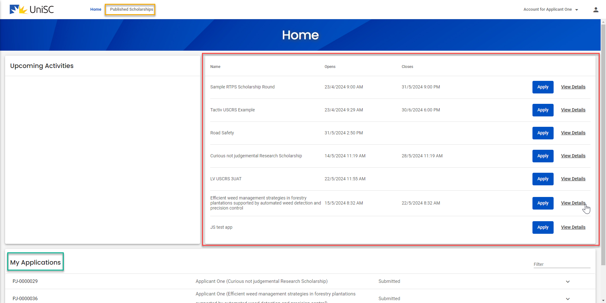

2) Once an applicant clicks on the appropriate “apply” button they will be taken to the application form for the chosen scholarship, the forms sections can be navigated through the use of the menu on the left hand side

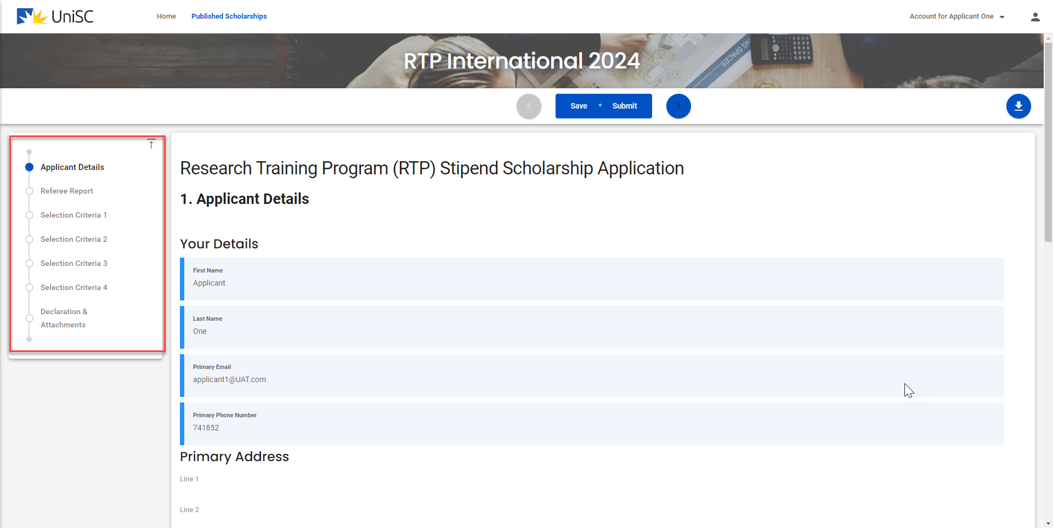

3) Ensure that as an applicant you are clearly responding to each of the selection criteria in the provided space, it is possible that each of the selection criteria will have multiple questions.

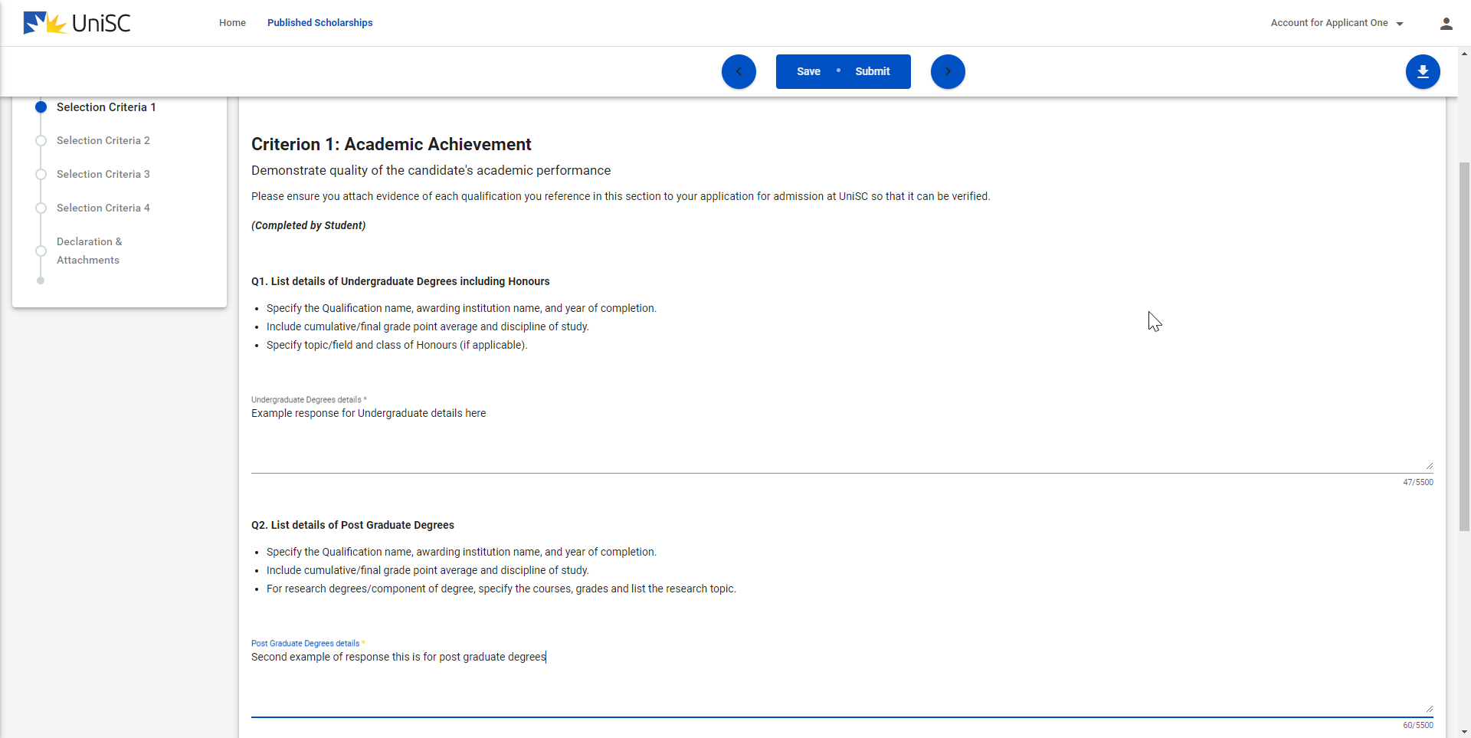

If you miss a required section, you will be prompted by the form and have your attention brought to the area which needs to be completed, and will be highlighted in red. Shown below is an example where an applicant has replied to question 2 but not question 3.

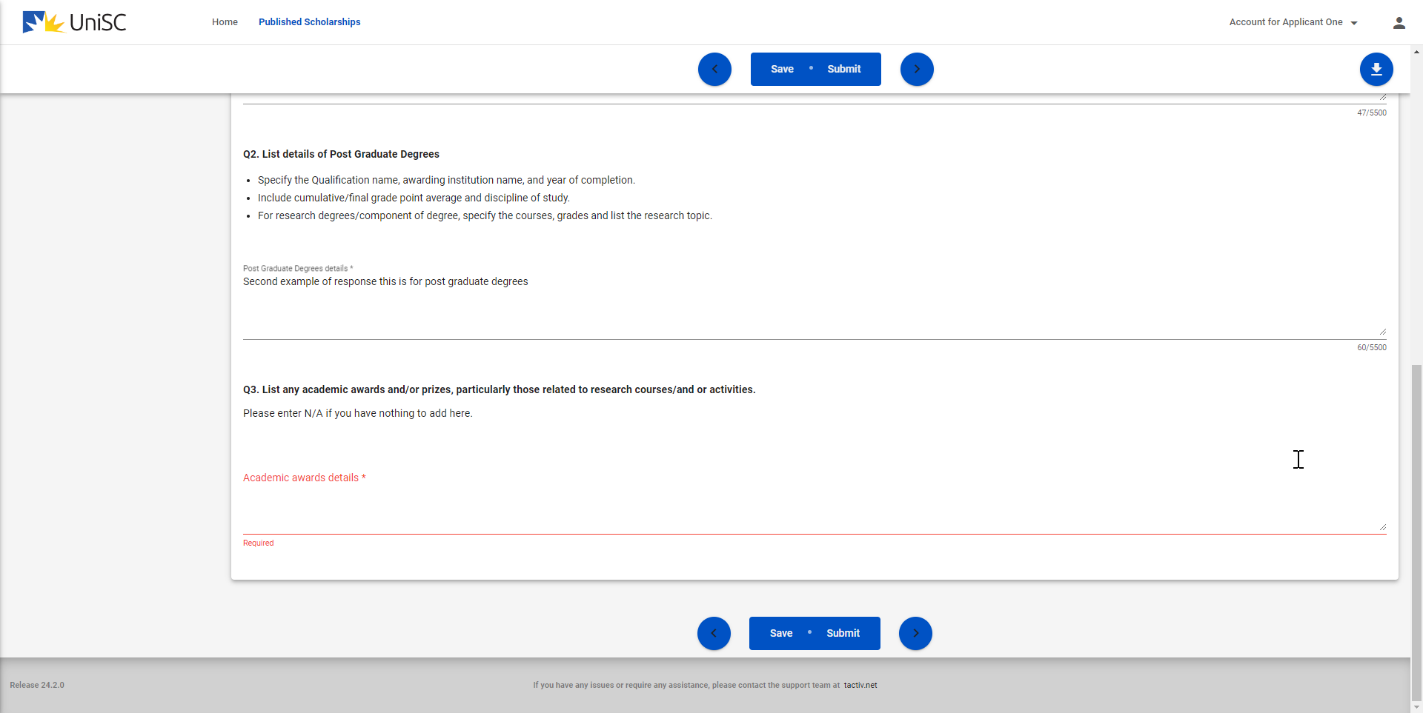

4) Once you have answered all questions, followed the related instructions, provided the required attachments, and confirmed that you agree to the terms, conditions and policies you will use the “Submit” button to complete.

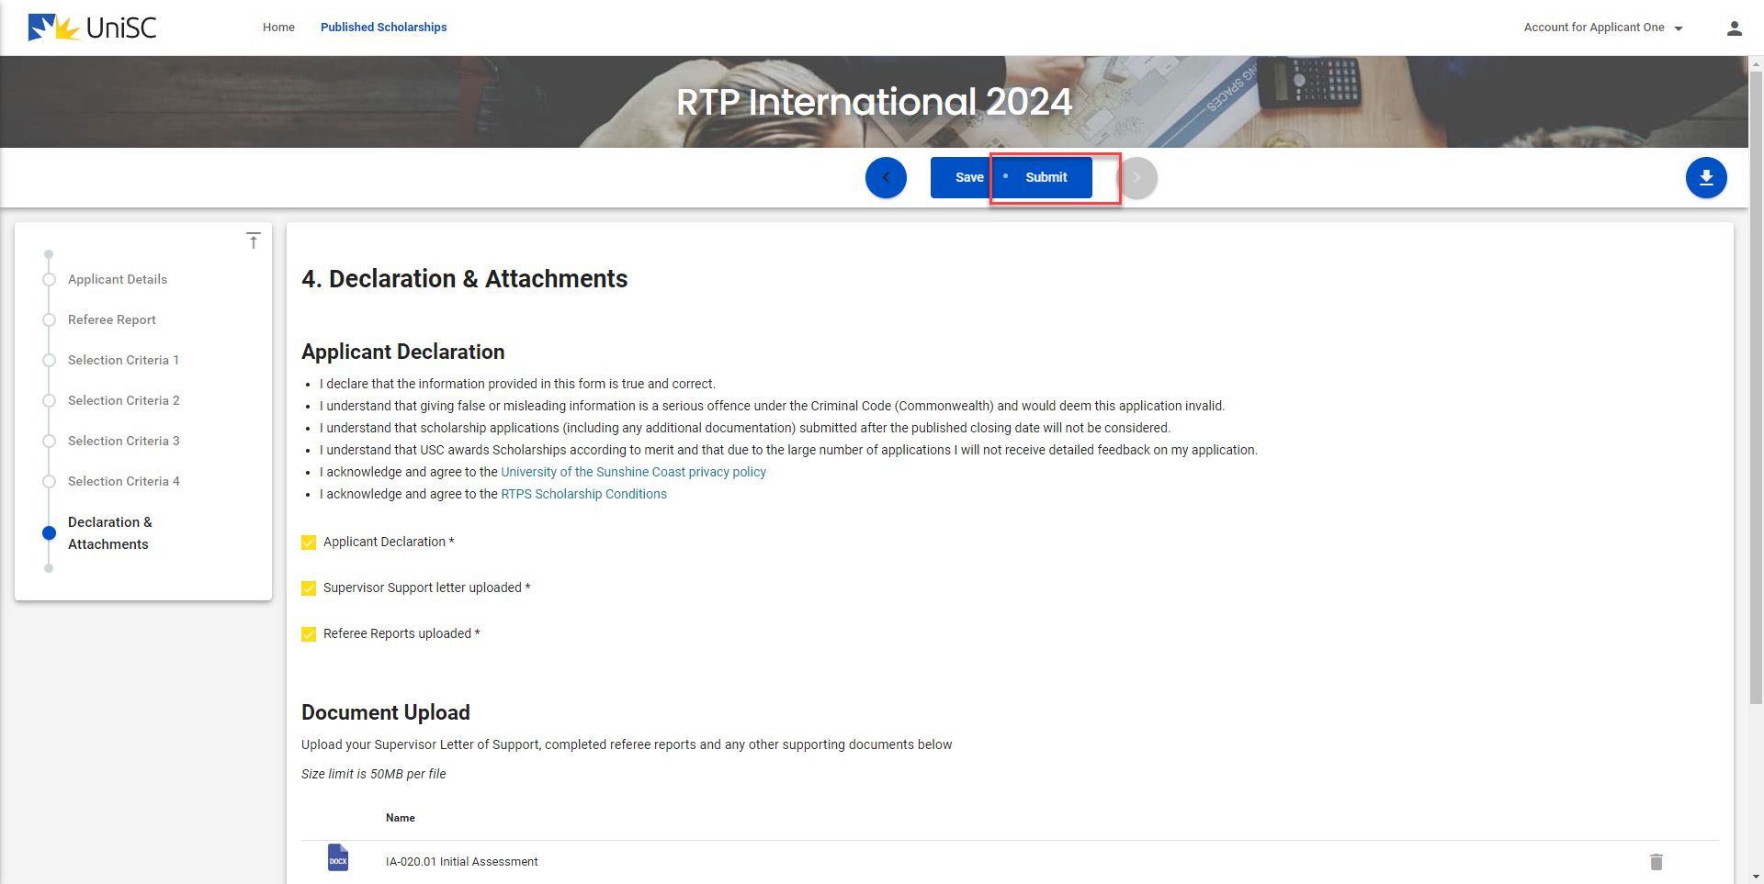

5) Upon submission you will be returned to the dashboard where you will be able to see your completed application under the My Applications toward the bottom of the dashboard.

